**Polymorphism** - means having many forms.  
Just like a man can be a father, brother, son at the same time.  
  
**It is of 2 types -**   
**1. Compile Time polymorphism 2. Run-time polymorphism**

* Function Overloading
* Operator Overloading

**Static binding** **-**   
It is the binding which can be resolved at compile time by compiler that is , here compiler knows for which particular method call which method is to be executed.  
It is also known as **early binding**, because this binding takes place before the program is executed.  
Eg - Method Overloading, etc.

**Dynamic Binding -**   
Compiler is not able to resolve the binding at compile time, so it is known as **late binding**.  
Here binding takes place at the time of program execution. Here compiler doesn’t know if it will encounter virtual function or not. **Eg -** Method Overriding

**Combined Eg -**

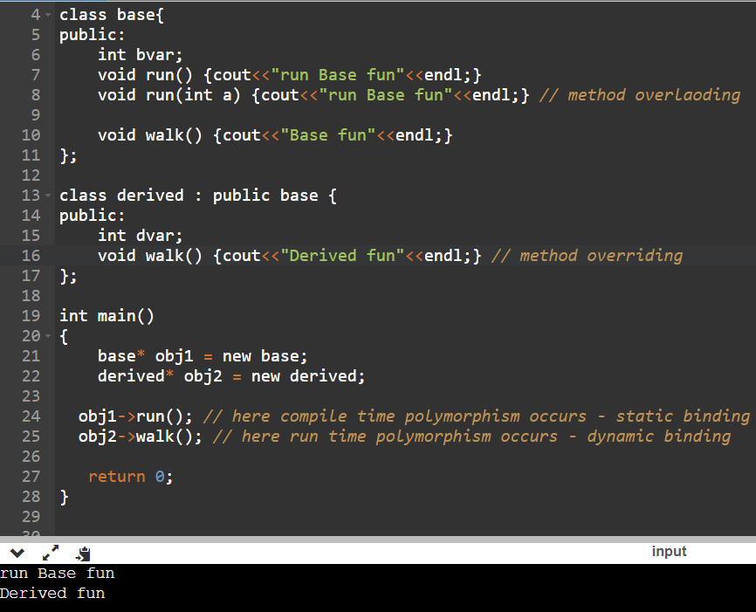

**Explanation –**

Here, during **method overloading**, the compiler knows which method is going to called.

In, **method overriding**, the compiler doesn’t know which ‘walk‘ function is going to be called.

**Virtual function -**   
Refer - <https://www.youtube.com/watch?v=m9p_shyDhY0&ab_channel=CppNuts>

refer - <https://www.youtube.com/watch?v=JU8DbwBvOWE&ab_channel=SimpleSnippets>  
  
It is a function which is declared within base class and is re-defined(overridden) by derived class.   
It ensures that the correct function is called for an object, regardless of the type of pointer used for function call.

When we call a **overridden function** using the object of derived class, then if that function is defined as virtual in the base class, then the derived class’s function will execute. Here dynamic binding is occuring

**Static binding - Dynamic binding -**

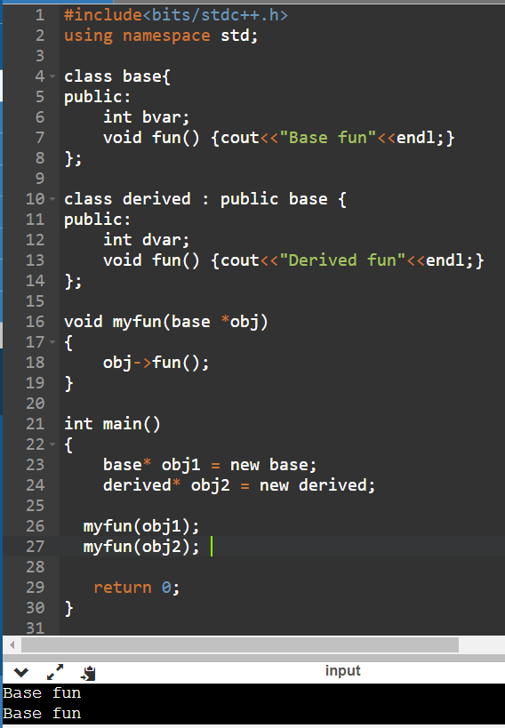 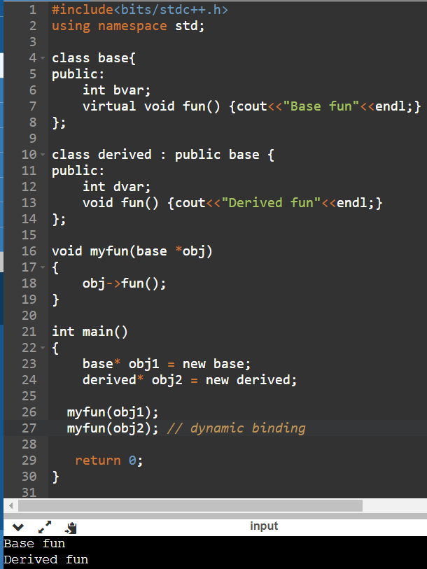

**Pure Virtual Function -**   
A pure virtual function in c++ is a virtual function for which we dont have implementation, we only declare it. It is declared by assigning 0 in declaration.  
Eg -   
We have a class shapes and it has a method to find area, but since every shape has a different formula to find area, so we make it pure virtual function so that we can declare in child clases.